What are class Diagrams?
Class diagrams are a type of UML (Unified Modeling Language) diagram used in software engineering to visually represent the structure and relationships of classes within a system i.e. used to construct and visualize object-oriented systems.
In these diagrams, classes are depicted as boxes, each containing three compartments for the class name, attributes, and methods. Lines connecting classes illustrate associations, showing relationships such as one-to-one or one-to-many.
Class diagrams provide a high-level overview of a system's design, helping to communicate and document the structure of the software. They are a fundamental tool in object-oriented design and play a crucial role in the software development lifecycle.

What is a class?
In object-oriented programming (OOP), a class is a blueprint or template for creating objects. Objects are instances of classes, and each class defines a set of attributes (data members) and methods (functions or procedures) that the objects created from that class will possess. The attributes represent the characteristics or properties of the object, while the methods define the behaviors or actions that the object can perform.

UML Class Notation
class notation is a graphical representation used to depict classes and their relationships in object-oriented modeling.
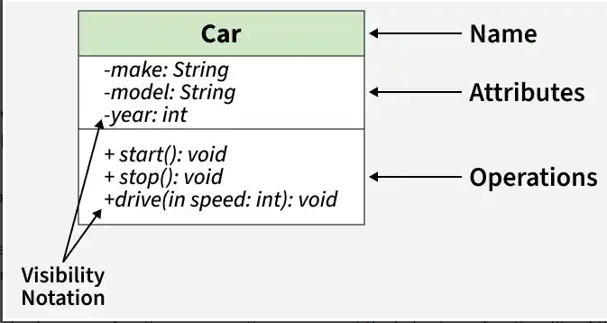
- Class Name:
  - The name of the class is typically written in the top compartment of the class box and is centered and bold.
- Attributes:
  - Attributes, also known as properties or fields, represent the data members of the class. They are listed in the second compartment of the class box and often include the visibility (e.g., public, private) and the data type of each attribute.
- Methods:
  - Methods, also known as functions or operations, represent the behavior or functionality of the class. They are listed in the third compartment of the class box and include the visibility (e.g., public, private), return type, and parameters of each method.
- Visibility Notation:
  - Visibility notations indicate the access level of attributes and methods. Common visibility notations include:
    - + for public (visible to all classes)
    - - for private (visible only within the class)
    - # for protected (visible to subclasses)
    - ~ for package or default visibility (visible to classes in the same package)
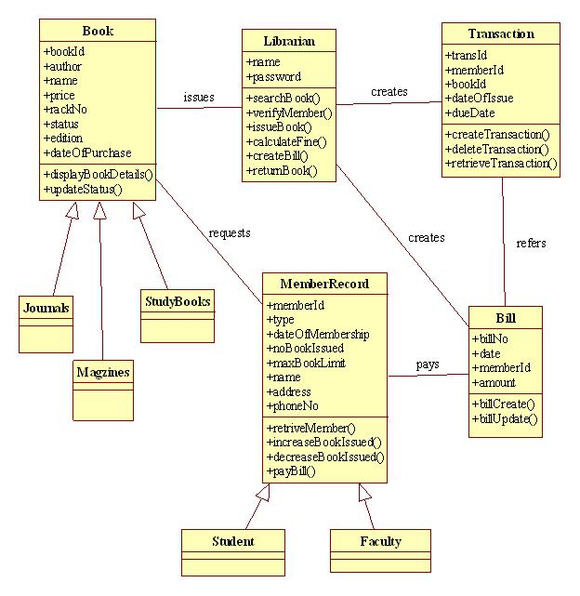

Relationships between classes
In class diagrams, relationships between classes describe how classes are connected or interact with each other within a system. Here are some common types of relationships in class diagrams:
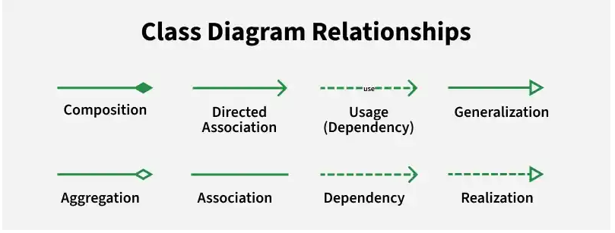Class Diagram Relationship

1. Association
An association represents a bi-directional relationship between two classes. It indicates that instances of one class are connected to instances of another class. Associations are typically depicted as a solid line connecting the classes, with optional arrows indicating the direction of the relationship.

2. Directed Association
A directed association in a UML class diagram represents a relationship between two classes where the association has a direction, indicating that one class is associated with another in a specific way.

3. Aggregation
Aggregation is a specialized form of association that represents a "whole-part" relationship. It denotes a stronger relationship where one class (the whole) contains or is composed of another class (the part). Aggregation is represented by a diamond shape on the side of the whole class. In this kind of relationship, the child class can exist independently of its parent class.

4. Composition
Composition is a stronger form of aggregation, indicating a more significant ownership or dependency relationship. In composition, the part class cannot exist independently of the whole class. Composition is represented by a filled diamond shape on the side of the whole class.

5. Generalization(Inheritance)
Inheritance represents an "is-a" relationship between classes, where one class (the subclass or child) inherits the properties and behaviors of another class (the superclass or parent). Inheritance is depicted by a solid line with a closed, hollow arrowhead pointing from the subclass to the superclass.

6. Dependency Relationship
A dependency exists between two classes when one class relies on another, but the relationship is not as strong as association or inheritance. It represents a more loosely coupled connection between classes.
e commerce calss diagram